

Cross Words

Monthly Newsletter of Cross Ev. Lutheran Church

December 2012 Volume 12, Issue 12

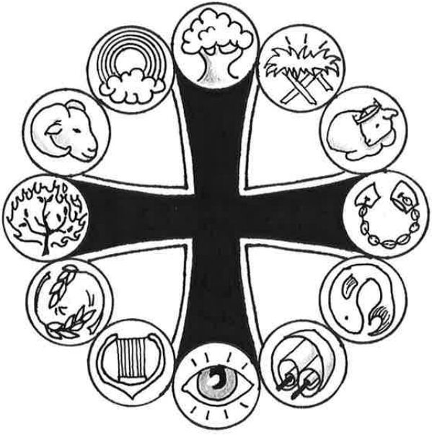

**Prominent People of the Bible**

***Mary***

*Mary treasured up all these things and pondered them in her heart.*

*(Luke 2:19)*

It’s Christmas time and there’s so much to wonder about.

Almost every child has snuck into the room to slide under the tree and gaze at the presents. “I wonder what they got me.” Tiny hands cannot be restrained from grasping and shaking the package to assess the contents. “If only I could see what’s in there.”

Can you imagine holding the baby Jesus on that first Christmas Eve? Mary didn’t have to sneak a peak or guess. She knew. He came from her, but he was sent from God. Mary compared what she’d been told with what was now happening. She couldn’t comprehend how the “contents” of this little package might affect her life but now she could see him. She marveled at the love of God. God with us! And then gazing into his precious face she embraced God’s Son, “Hello Jesus. Welcome to your new home.”

One Friday, 33 years after Mary pondered the miraculous birth of the Son of God, she had to say goodbye. She watched him go. She believed that his innocent death covered the guilt of every sin. She knew that she couldn’t keep him here because he belonged there on the throne with his Father. She remembered, like only a mother can remember, everything that was said of him, everything that was done to him, everything he had told her. Deep in her heart she trusted that she would see him again and hear him return the greeting, “Hello mother, welcome home.”

Part of the mystery of Christmas is learning how to say hello to Jesus before you have to say goodbye. His coming has changed our going. His greeting on the other side ties directly to our believing that he came to save us sinful human beings. “Hello, welcome home,” he’ll say to all who trust him as Savior. And the gift of eternal life which he bought for us by his birth, life, and death will be completely unwrapped.

Join Mary in gazing at this wonderful Child by reading Luke 2. Take a bit more time to ponder what’s in God’s special “present” by worshiping with us this Christmas.

**Graphic for Mary: *Manger***

Mary's role in God's plan for salvation was to give birth to Jesus. The manger reflects Jesus' humble birth.

**More information is located online at WhatAboutJesus.com. Look for the *What About … Prominent People* link.**

**THE VISIBLE CHURCH**

Invisible Except to God

I’m not the only one. There are many, many more like me. Young and old, rich and poor, past, present, and future, Lutheran, Baptist, Catholic—they make up God’s church. Who are these people? The word *church* tells me. In the original it means “called out.” God’s church is composed of all those whom he has called out of unbelief to faith. That’s how Peter described it in his first epistle. He wrote, “You are . . . a people belonging to God, that you may declare the praises of him who called you out of darkness into his wonderful light” (2:9).

This church belongs to God. In his marvelous grace, he calls people to faith. That faith is not generic as if what is believed doesn’t matter. Very specifically Jesus says, “I am the way. . . . No one comes to the Father except through me” (John 14:6). In confirmation class, I would tell the children, “Remember *A, B, C,* and you will know what the church is.” It is All Believers in Christ. Only those in whose hearts God’s grace has worked faith in Jesus as their all-sufficient Savior belong to his church.

But that makes his church invisible. I can look into my own heart, but not into someone else’s to see whether such faith exists there. Only God can do that. Paul said it simply, “The Lord knows those who are his” (2 Timothy 2:19). Every time I say the words of the Apostles’ Creed, I remind myself of this truth. I don’t say, “I see,” but rather, “I believe in . . . the holy Christian Church, the communion of saints.” Though Scripture doesn’t use the term *invisible,* the concept is there. Only God can see who the ABCs truly are.

Am I a member of God’s church? For the answer it’s best to look more at God’s heart than at my own. In his Word he has laid open his heart to me. What does he show me in his Word? “I have loved you with an everlasting love; I have drawn you with loving-kindness,” he assures me (Jeremiah 31:3). When I look into God’s heart, it’s love that I see, not just for the world but also for me! Love that sent his Son not only to pay for the sins of the world but also for mine. Love that sends his Spirit to work faith not just in the hearts of others but also in mine. Love that has united me with many others in his holy Christian church.

© 2012 Northwestern Publishing House. All rights reserved.

Scripture is taken from THE HOLY BIBLE, NEW INTERNATIONAL VERSION.®

**Christmas For Kids**



**All Aboard the Bethlehem Express!**

**Crafts, Carols, Games, Refreshments**

**AND the Christmas Story!!**

**For Children of Sunday School Age**

***December 15, 12:00 pm – 3:30 pm***

**Cross Lutheran Church**

**6001 Main St. Rockford, MN**

**FREE**

**Log on to** [**www.crosslutheranwels.org**](http://www.crosslutheranwels.org)

**Or call 763-477-5981 or Sign up at church**

**PEACE**

*For to us a child is born, to us a son is given, and the government will be on his shoulders. And he will be called . .* ***. Prince of Peace****.*

*(Isaiah 9:6)*

*“Glory to God in the highest, and on earth* ***peace*** *to men on whom his favor rests.”*

(Luke 2:14)

One of the many Christmas words is “peace”. It’s part of prophecy – the words of Isaiah - and part of fulfillment – the song of the Bethlehem angels. The word is found in many a Christmas decoration.

Yet every Christmas season some news or social commentator will point to the violent acts of society or a warring part of the world and claim that “peace” is an unfulfilled Christmas wish.

Nothing could be farther from the truth. The violence and warfare of the world are indeed evidence of the need for peace, but not just or most importantly peace among mankind. The violence and war are a sign of sin and the sinful human nature in action (along with greed, lust selfishness, lies, etc.) This puts us at war with God, who hates sin and whose holiness demands that it be punished. But our holy God is also a loving God. He promised peace in and through the Savior. That is what He gave us in Jesus His Son. The One born in Bethlehem’s manger went to Calvary’s cross to be punished for our sins. In the midst of the peaceful nativity scene God was reconciling the world to Himself in Jesus, not counting our sins against us, but placing them on His Son instead. The “peace” of Christmas is the forgiveness of sins. It is peace between us and God. It is peace of mind and heart that comes from faith in Jesus.

I have told the story of the little boy, praying the Lord’s Prayer, who said, “And forgive us our Christmases”. How often don’t we find ourselves getting caught up in the hustle and bustle, the materialism and commercialism of the “season” instead of being swept away by the Spirit of God and the real message of the season? Sometimes we need forgiveness for our Christmases. In Jesus we have it and along with the forgiveness of our sins, the real peace of Christmas.

“Peace” – it is not an unfulfilled hope or promise. It is why Jesus came. It is what we have in Him. He is the Prince of Peace.”

**NEWS FROM CHURCH**

**NEW PIANO –** The new piano in the church has been purchased by the choir. Funds to purchase this piano came from memorials and proceeds from Easter Breakfasts saved up for several years. We thank those who made donations to the choir and pray that the Lord will bless its use to the praise and glory of His name!

**DONATIONS FOR WINDOWS** Anyone wishing to make a donation towards the replacement window project should contact Doug Roush or Jim Reader for details.

C:\Users\church office\AppData\Local\Microsoft\Windows\Temporary Internet Files\Content.IE5\XCG8FXOE\MC900078838[1].wmf “Hanging Of The Greens”

The annual “Hanging of the Greens” activities will be held on Sunday, Dec 2.

We will start at noon with a pot luck dinner. Bring a hot dish, salad or dessert to share.

After dinner we will put up the Christmas decoration in and around the church.

After decorating, we hope to get a group together to go caroling at the Parkview and Lake Ridge Care Centers in Buffalo.

***All members are invited and encouraged to come and take part in the fun and fellowship.***

**December Worship Schedule**

**Children’s Christmas Service; Dec 23 @ 9:00 am**

**Christmas Eve Worship @ 4:00 pm & 7:00 pm**

**Christmas Day Worship @ 9:00 am**

There will be NO Wednesday service on December 19th & 26th .

Please note that due to the special worship schedule, the Lord’s Supper will be celebrated on the following dates in December: Wednesday, Dec 5; Sunday, Dec 9; Sunday December 30th and Monday, December 31st.

Starting with the 3rd week in January, 2013, we will return to the regular communion schedule of the 1st & 3rd weeks of the month.

**NEWS FROM WEST LUTHERAN HIGH SCHOOL**

[](http://wlhs.us2.list-manage.com/track/click?u=816d0f6a8e429de9f40bf38a3&id=80d2a5e052&e=b1960f19f7)

**CHRISTMAS CONCERT:** All are invited to attend this year's Christmas Concert **THURSDAY**, **DECEMBER 13TH AT 7:30 PM** (pre-concert music prior).  This year's theme is "Sing We Now of Christmas".  Concert Band, Freshman Choir, Concert Choir, and Western Accents will all be performing.

C:\Users\church office\AppData\Local\Microsoft\Windows\Temporary Internet Files\Content.IE5\QNHFUVEZ\MC900411085[1].wmf

**CROSS LIGHTS CHRISTMAS PARTY**

Cross LIGHTS will hold its annual Christmas Party on Tuesday, December 4th at 7:30 pm. All the women of the congregation are invited to attend. Those attending are asked to bring a favorite appetizer to share; an item for the food shelf; and if you have a special or unique nativity set, to bring that along.

|  |
| --- |
| **Dreaming of Diamonds**  One Christmas morning a woman told her husband, “I just dreamed that you gave me a beautiful diamond necklace. What do you think it means?” “You’ll know tonight,” he said. That evening just before opening presents, the husband came home with a small package and gave it to his wife. Delighted, she opened it only to find a book entitled “The Meaning of Dreams.” |
|  |

**Family Trees**

A little girl asked her mother, "How did the human race appear?' The mother answered, 'God made Adam and Eve and they had children and so was all mankind made." Two days later the girl asked her father the same question. The father answered, "Many years ago there were monkeys from which the human race evolved."   
 The confused girl returned to her mother and said, "Mom, how is it possible that you told me the human race was created by God, and Dad said they developed from monkeys?" The mother answered, "Well, dear, it is very simple. I told you about my side of the family and your father told you about his."

**Early Shopping**

It was nearly Christmas and the Judge was in a happy mood. She asked the defendant, "What are you being prosecuted for?" "Doing my Christmas shopping too early," replied the defendant. "That's not a crime," replied the Judge. "How early were you doing you Christmas shopping?" "Before the store opened," replied the defendant!!